SUBMITTAL DATA SHEET
AUX R32 – C-Series - AJAN09HP115V1C
Job Name | Location Date
Purchaser | Engineer
Submitted to | For □Reference □Approval □Construction
Unit Designation | Schedule #

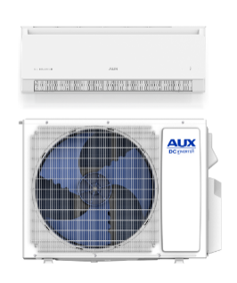
- AHRI No: 214290025

AJAN09HP115V1C

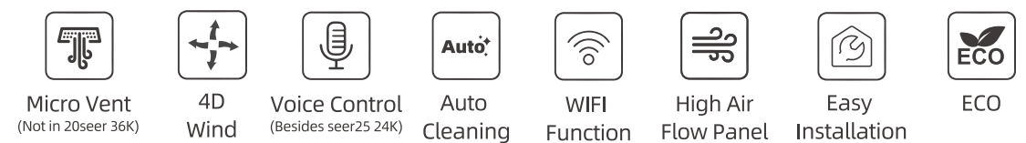

Specifications
Model |  |  |  | AJAN09HP115V1C
Indoor Unit |  |  |  | AJAN09HP115V1CH
Outdoor Unit |  |  |  | AJAN09HP115V1CO
Cooling | Capacity | Rated | Btu/h | 9100
Cooling | Capacity Range | Min-Max | Btu/h | 1700~12000
Cooling | Power Input | Rated | W | 800
Cooling | Operating Range | °F |  | 5-125
Heating | Capacity at 47F | Rated | Btu/h | 9500
Heating | Capacity Range | Min-Max | Btu/h | 1700~14000
Heating | Power Input at 47F | Rated | W | 800
Heating | Capacity at 17F | Rated | Btu/h | 9400
Heating | Capacity at 5F | Max | Btu/h | 9000
Heating | Capacity at -5°F | Max | Btu/h | 5800
Heating | Operating Range | °F |  | -13-75
Efficiency | SEER2 |  |  | 20
Efficiency | HSPF2 |  |  | 8.5
Indoor Unit | Air Flow Rate(SH/H/M/L/Q) |  | CFM | 355/315/282/255/180
Indoor Unit | Sound Pressure Level | Cooling | dB(A) | 41/36/34/31/26
Indoor Unit | Sound Pressure Level | Heating | dB(A) | 41/36/33/29
Indoor Unit | Package Dimensions | H | In.[mm] | 11-71/64 [282]
Indoor Unit | Package Dimensions | W | In.[mm] | 32-23/32 [831]
Indoor Unit | Package Dimensions | D | In.[mm] | 14-39/64 [371]
Indoor Unit | Net Dimensions | H | In.[mm] | 7-61/64 [202]
Indoor Unit | Net Dimensions | W | In.[mm] | 30-15/32 [774]
Indoor Unit | Net Dimensions | D | In.[mm] | 11-47/64 298]
Indoor Unit | Net Weight | Ibs[kg] |  | 17.7 [8]
Outdoor Unit | Package Dimensions | H | In.[mm] | 23-27/64 [595]
Outdoor Unit | Package Dimensions | W | In.[mm] | 32-31/64 [825]
Outdoor Unit | Package Dimensions | D | In.[mm] | 13-37164 [345]
Outdoor Unit | Net Dimensions | H | In.[mm] | 21-3/16 [538]
Outdoor Unit | Net Dimensions | W | In.[mm] | 31-11/16 [805]
Outdoor Unit | Net Dimensions | D | In.[mm] | 12-11/64 [309]
Outdoor Unit | Net Weight | Ibs[kg] |  | 51.8 [23.5]
Outdoor Unit | Sound Pressure Level | Cooling | dB(A) | 51
Outdoor Unit | Sound Pressure Level | Heating | dB(A) | 51
Piping | Diameter | Gas(0.D.) | In.[mm] | 3/8 [9.52]
Piping | Diameter | Liquid(0.D) | In.[mm] | 1/4 [6.35]
Piping | Diameter | Indoor Drain | In.[mm] | 5/8 [15.88]
Piping | Min.Length | ft [m] |  | 9 [2.74]
Piping | Max.Length | ft [m] |  | 65 [20]
Piping | Max.Height | ft [m] |  | 50 [15]
Electrical | Outdoor-Indoor | V,ph,Hz |  | 115,1,60
Electrical | Recommended Breaker Size | A |  | 25
Electrical | MCA | A |  | 15
Electrical | MOCP | A |  | 25
Refrigerant | Refrigerant Type |  |  | R32
Refrigerant | Pre-Charge Amount oz |  |  | 30
Refrigerant | Additional Charge Per Foot over 25ft |  |  | 0.172oz/ft
Remarks:
1.All specifications are subject to change by the manufacturer without prior notice.
2.All units are being tested and comply to ISO5151.
3.Sound pressure levels are measured in anechoic chamber.
During actual operation, sound pressure level will be higher as a result of room specification condition.
4.Data from AUX lab,05/03/24, Data may change according to test surroundings, AUX reserves right of explanation on data.



Dimensions
Indoor Unit:
AJAN09HP115V1CH
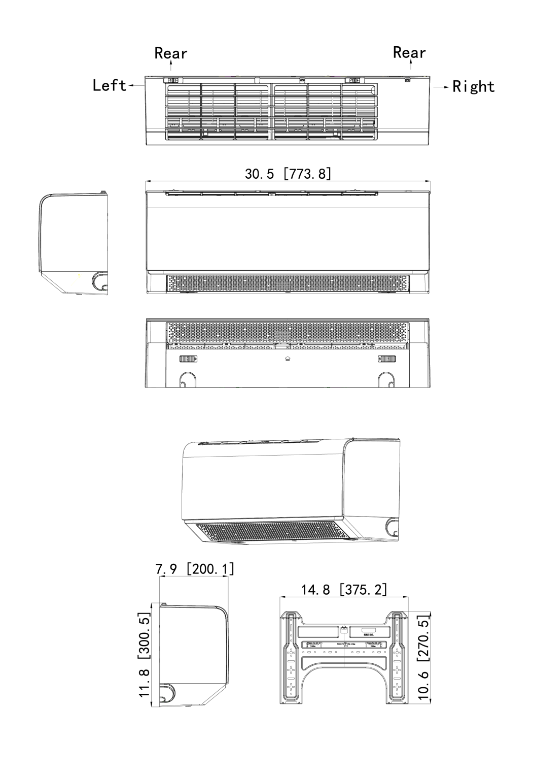
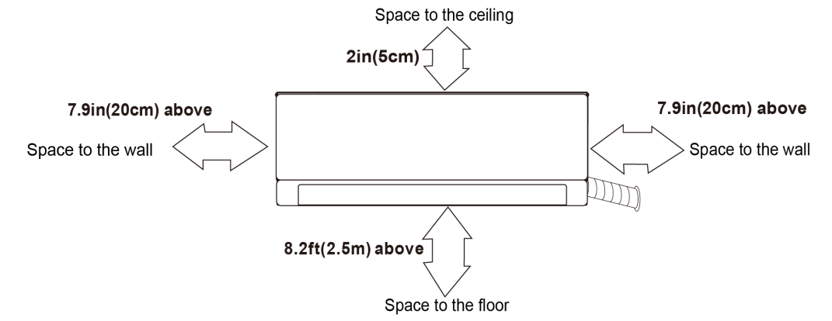

Dimensions
Outdoor Unit:
AJAN09HP115V1CO
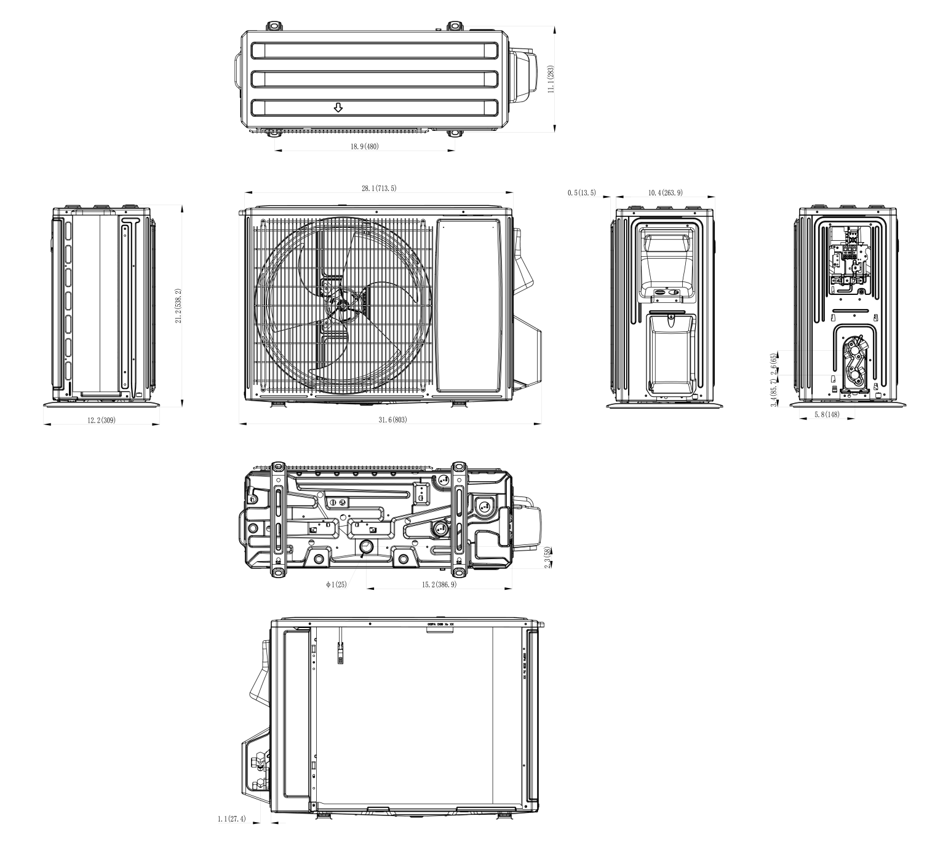

Clearances
Outdoor Unit:
AJAN09HP115V1CO
