SUBMITTAL DATA SHEET
AUX R32 – C-Series - AJAN12HP230V1C
Job Name | Location Date
Purchaser | Engineer
Submitted to | For □Reference □Approval □Construction
Unit Designation | Schedule #

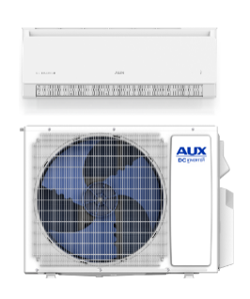
- AHRI No: 214290013

AJAN12HP230V1C

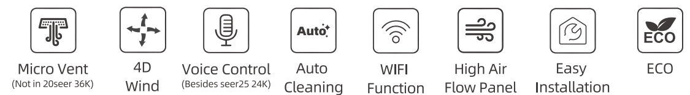

Specifications
Model |  |  |  | AJAN12HP230V1C
Indoor Unit |  |  |  | AJAN12HP230V1CH
Outdoor Unit |  |  |  | AJAN12HP230V1CO
Cooling | Capacity | Rated | Btu/h | 12000
Cooling | Capacity Range | Min-Max | Btu/h | 1700-13300
Cooling | Power Input | Rated | W | 1212
Cooling | Operating Range | °F |  | 5-125
Heating | Capacity at 47F | Rated | Btu/h | 12300
Heating | Capacity Range | Min-Max | Btu/h | 1700-15000
Heating | Power Input at 47F | Rated | W | 1.030
Heating | Capacity at 17F | Rated | Btu/h | 9800
Heating | Capacity at 5F | Max | Btu/h | 9200
Heating | Capacity at -5°F | Max | Btu/h | 6100
Heating | Operating Range | °F |  | -13-75
Efficiency | SEER2 |  |  | 21
Efficiency | HSPF2 |  |  | 8.8
Indoor Unit | Air Flow Rate(SH/H/M/L/Q) |  | CFM | 380/330/302/273/193
Indoor Unit | Sound Pressure Level | Cooling | dB(A) | 43/40/36/33/27
Indoor Unit | Sound Pressure Level | Heating | dB(A) | 43/40/36/33
Indoor Unit | Package Dimensions | H | In.[mm] | 11-7/64 [282]
Indoor Unit | Package Dimensions | W | In.[mm] | 35-5/64 [891]
Indoor Unit | Package Dimensions | D | In.[mm] | 14-39/64 [371]
Indoor Unit | Net Dimensions | H | In.[mm] | 7-61/64 [202]
Indoor Unit | Net Dimensions | W | In.[mm] | 32-53/64 [834]
Indoor Unit | Net Dimensions | D | In.[mm] | 11-47/64 [298]
Indoor Unit | Net Weight | Ibs[kg] |  | 18.8 [8.5]
Outdoor Unit | Package Dimensions | H | In.[mm] | 23-27164[595]
Outdoor Unit | Package Dimensions | W | In.[mm] | 32-31/64 [825]
Outdoor Unit | Package Dimensions | D | In.[mm] | 13-37/64 [345]
Outdoor Unit | Net Dimensions | H | In.[mm] | 21-3/16 [538]
Outdoor Unit | Net Dimensions | W | In.[mm] | 31-11/16 [805]
Outdoor Unit | Net Dimensions | D | In.[mm] | 12-11/64 [309]
Outdoor Unit | Net Weight | Ibs[kg] |  | 55.1 [25]
Outdoor Unit | Sound Pressure Level | Cooling | dB(A) | 52
Outdoor Unit | Sound Pressure Level | Heating | dB(A) | 52
Piping | Diameter | Gas(0.D.) | In.[mm] | 3/8 [9.52]
Piping | Diameter | Liquid(0.D) | In.[mm] | 1/4 [6.35]
Piping | Diameter | Indoor Drain | In.[mm] | 5/8 [15.88]
Piping | Min.Length | ft [m] |  | 9 [2.74]
Piping | Max.Length | ft [m] |  | 65 [20]
Piping | Max.Height | ft [m] |  | 50 [15]
Electrical | Outdoor-Indoor | V,ph,Hz |  | 208/230,1,60
Electrical | Recommended Breaker Size | A |  | 15
Electrical | MCA | A |  | 10
Electrical | MOCP | A |  | 15
Refrigerant | Refrigerant Type |  |  | R32
Refrigerant | Pre-Charge Amount oz |  |  | 21
Refrigerant | Additional Charge Per Foot over 25ft |  |  | 0.172oz/ft
Remarks:
1.All specifications are subject to change by the manufacturer without prior notice.
2.All units are being tested and comply to ISO5151.
3.Sound pressure levels are measured in anechoic chamber.
During actual operation, sound pressure level will be higher as a result of room specification condition.
4.Data from AUX lab,05/03/24, Data may change according to test surroundings, AUX reserves right of explanation on data.



Dimensions
Indoor Unit:
AJAN12HP230V1CH
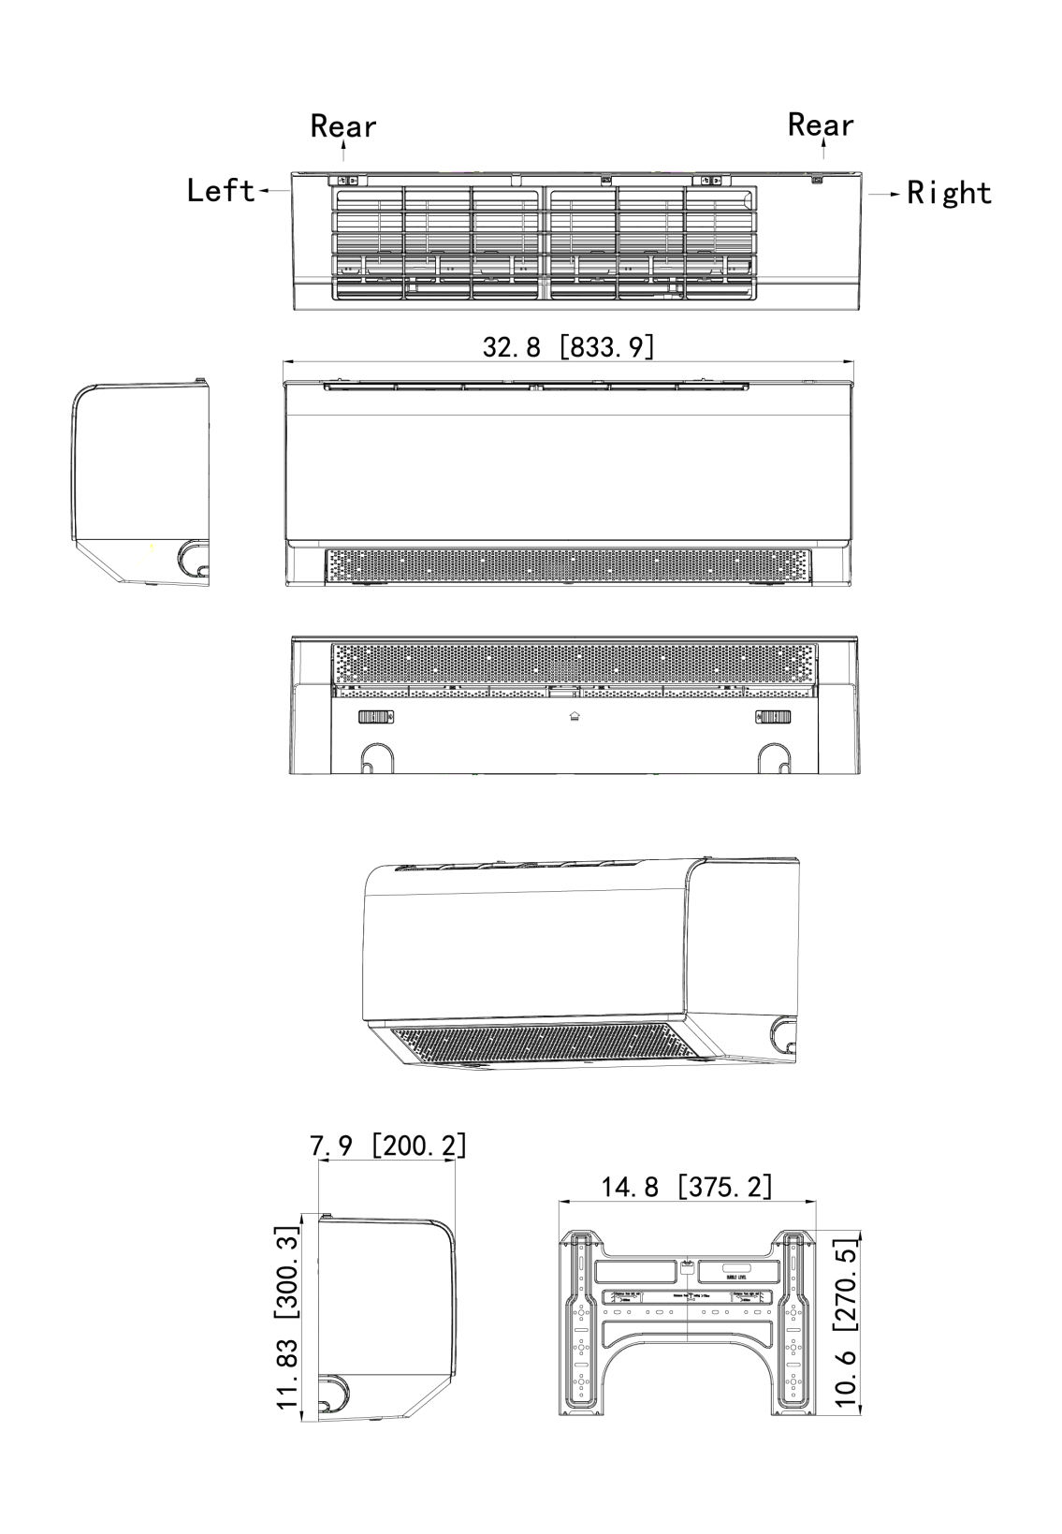
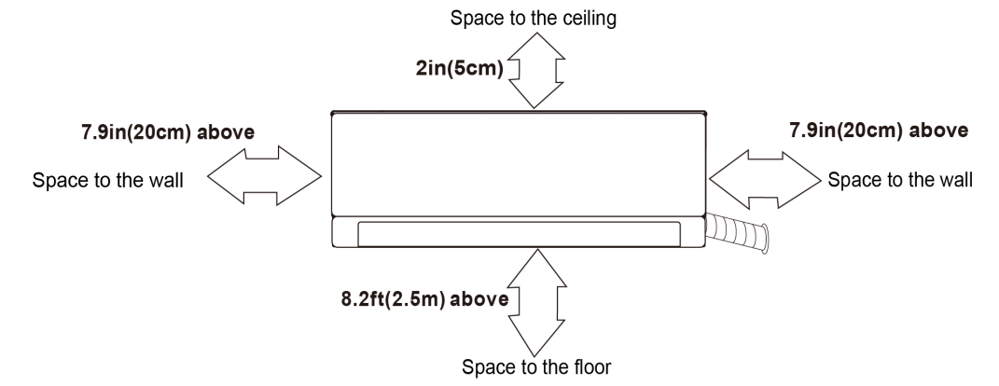

Dimensions
Outdoor Unit:
AJAN12HP230V1CO
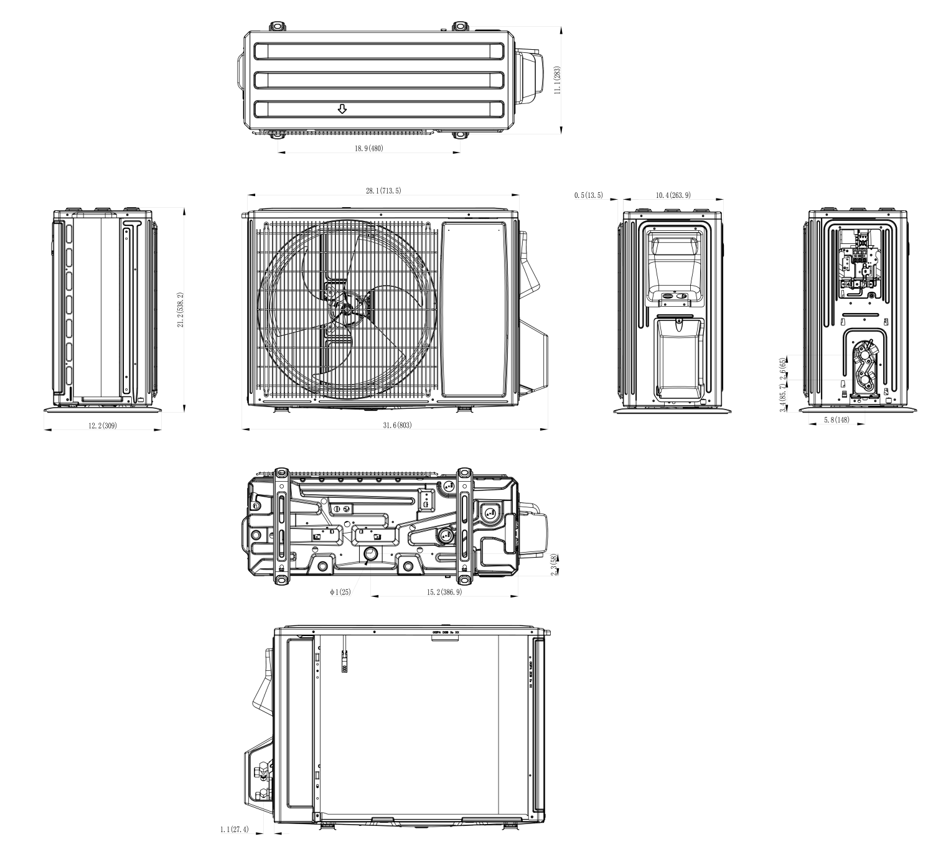

Clearances
Outdoor Unit:
AJAN12HP230V1CO
